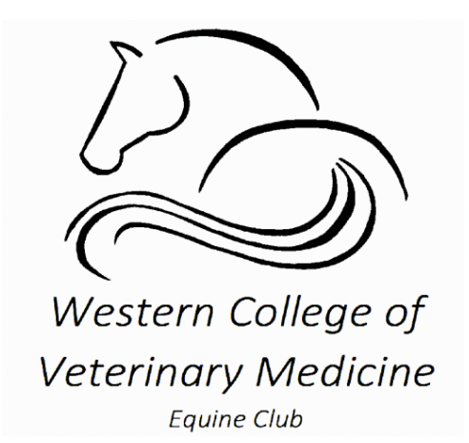
PLEASE NOTE:
Due to the associated costs and planning that are necessary to prepare for this event, the WCVM Equine Club will not be offering refunds. We apologize for this inconvenience and will be sure to have the event package sent to any members that cannot attend due to unforeseen circumstances. Please be advised there is no videotaping or photos allowed at this event. Thank you for your understanding.

Liability waiver

Please complete one of these per participant.

I, ________ give full consent that my son/ daughter can participate in all horse handling activities. I understand that handling and working with horses is dangerous, and although the Western College of Veterinary Medicine will do everything they can to keep my son/daughter safe, that injury can occur. I will not hold the Western College of Veterinary Medicine staff, faculty or students accountable for any injury or accident that occurs during the events
on March 11th, 2023.

Signature: ____ ____ Date: __________

