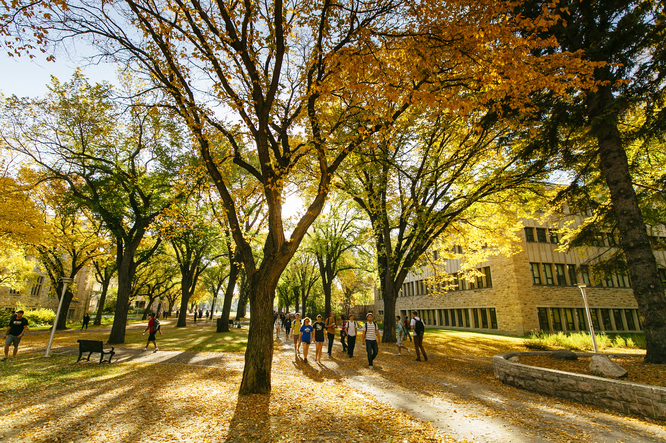­



**Externship Program**

**VINT 580**

**Policies & Procedures**

**WCVM Class of 2023**

**VINT 580 Externship Program**

**A. Introduction**

1. Definition

A VINT 580 Externship is a rotation that occurs away from the WCVM and is under the supervision and responsibility of someone other than a WCVM faculty member.

1. Aims and Objectives of Externships

The opportunities available within the College are more than adequate to provide students with an excellent clinical education. Participating in an externship is not essential to ensure a "complete" education. The time spent away from the College on an externship, however, is valuable and it should be preceded with careful thought and planning.

Externships are intended to enhance and enrich the 4th year curriculum and to allow students the opportunity to gain a greater depth of knowledge in an area of their particular interest. Externships can also be used to augment experiences gained at the WCVM or to take advantage of opportunities not readily available within the fourth year program.

The emphasis of the experience should be on learning principles, problem solving and gaining knowledge and experience. As a general rule, the more specialized the externship, the higher the likelihood the student’s role will be observation.

Among other learning outcomes, externships should provide experience in the diagnosis and treatment of clinical cases, practical experience in the management of cases, opportunities to develop technical skills, and the opportunity to observe, develop and demonstrate professional attitudes and behaviours. All opportunities must be hands on clinical experiences and may not contain a research focus.

1. Examples of Possible Externship Experiences

Several different options are available for externships and the following are the types that have previously been approved. Other proposals may be considered provided they fit the overall philosophy of the program.

Academic Institutions - these usually center on specialties or subspecialties that are not offered or limited at the WCVM. Examples of these would include cardiology, neurology, dermatology, aquaculture and fish disease.

Unique Opportunities - experiences such as marine aquariums, wildlife research centers, research institutes, etc.

Private Practices - these are practice situations where a specific case load/expertise combination would allow students to gain an in-depth knowledge of a certain field of veterinary medicine. In considering this option, students should give careful thought to the potential cost/benefit balance of the proposal. In general, the externship supervisor (in this case the private practitioner) should be highly experienced in their particular field and working in a high quality practice. The supervisor should be a good role model with a sincere interest in teaching and established expertise in the area of the proposed experience.

4. Qualifications of Externship Supervisor

An externship supervisor would normally have at least five years of experience in the field of the proposed externship. There should be clear evidence of specialization which may be board certification in a specific discipline, completion of a clinical residency program, or established experience and expertise gained through the practice of professional skills.

**B. General Policies**

1. Rotations will be either two or four weeks in duration.
2. When considering an externship, students should ensure that the experience they are applying for is one they prioritize over all others. Externships will be placed in to the student draft prior to the knowledge of placement and availability of other opportunities. Externships will not be moved once dates are approved (barring extenuating circumstances such as emergent health issues, natural disaster, etc.).
3. The specific timing of the rotation must not conflict with the schedule for the fourth year program. (i.e. – externships must fall within the weekly blocks as laid out in the Academic Calendar). Students may arrange externships over the summer with the understanding that they **must** have successfully passed all third year course requirements and registered in the appropriate VINT 580 term. If a student requires a supplemental exam, all externships (and any other selected rotations) in the summer will be cancelled while externships during the regular academic year will be held as tentative within their schedule pending the successful completion of the supplemental exam.
4. Externships may **not** be scheduled in the last two weeks of the academic year.
5. Arrangements for travel must be such that they have no effect on the adjacent rotations.
6. All documentation must be completed before the externship will be submitted for approval.

**C. Important Insurance Issues**1. Professional Liability Insurance

The liability policy includes “professional services” coverage which protects the students from lawsuits or claims which may arise in respect of any professional activity in which they are so engaged, in furtherance of their education or training.

The University of Saskatchewan’s professional liability insurance policy covers all registered students while in pursuit of their academic requirements, performing any duty or taking part in any activity which is considered part of regular or extraordinary studies connected with the University. This policy then will be effective if you are on an approved externship, under approved supervision, and if your externship is taking place in Canada or anywhere other than the United States.

**The University of Saskatchewan’s policy does not cover externships in the USA**. It will be necessary for those students participating in externships in the United States to obtain liability insurance. (Refer to Section J)

1. Travel Insurance

Travel Insurance is provided by the University for students travelling on University business. This insurance covers the trip (“in-transit”) portion only. Once you have arrived at your destination the coverage no longer applies. The University’s Office of Risk Management and Insurance Services must be provided with written details of the travel itinerary prior to the trip taking place. The following information should be provided: Student name(s), destinations, dates and a brief description of the purpose of the travel. Student Services will provide forms to collect this information once the externship has been approved.

1. Medical Services and Health Insurance

The University does not provide any insurance coverage of this sort. You are encouraged to make sure that your provincial health plan covers you for your medical and health services costs while you are attending the University of Saskatchewan. (DVM students should also ensure that their provincial health plans provide coverage at elective and externship locations).

All full-time students are automatically enrolled in the USSU Student Health & Dental Plan. The maintenance and adequacy of such coverage is the responsibility of the student.

All student participants are required to provide evidence of valid out-of-country medical health insurance through the International Travel Registry service prior to travel. The insurance must provide coverage for the full duration of travel, and include coverage for medical evacuation and repatriation.

1. Disability Insurance

Disability insurance is not provided.

**Note:** Other types of insurance such as disability insurance or life insurance are not provided to undergraduate or graduate students by the University of Saskatchewan. For example, if you are permanently or temporarily disabled while pursuing your academic program or while working in the Clinics, the University does not provide for disability insurance (or for life insurance).

For information regarding the purchase of disability or life insurance consult your insurance broker. A CVMA package is available for veterinarians; for more information contact the CVMA.

**D. Responsibilities of the Student**

1. Externships are to be considered a privilege. Students should consider themselves representatives of the WCVM and conduct themselves in a manner that will reflect positively on the College. Students will not be able to cancel or be excused from externships without providing the Associate Dean Clinical Programs with notice of personal or family crisis.
2. All costs and arrangements for travel, accommodation, food and any other costs associated are the student's sole responsibility. You should be aware that when travelling to the United States or any other international country, the possibility exists that you may encounter problems crossing the border and be returned to Canada. Students travelling outside of North America should check visa regulations and requirements.
3. Complete the application process as in Section H - Application procedures.
4. Submit all required and completed documentation prior to **January 28th** of their third year. (See Section I – Documentation)
5. When students are notified of the final decision of approval, they will be required to complete and sign a Travel Insurance Form. Those students travelling outside of Canada will be required to complete additional forms which will be distributed at a later date. These forms are itemized in Section J - Forms Required after Final Decision of Approval.

All forms must be complete prior to departure. Failure to do so may result in cancellation of the externship.

1. Prior to leaving, students must ensure they have reviewed all relevant lecture material and reviewed procedural and technical skills.
2. Ensure they have the appropriate vaccinations, protective clothing and footwear plus basic equipment such as stethoscope, thermometer, etc.
3. **During the externship students must maintain a case/activity log that must be verified by the Externship Supervisor on completion of the rotation.** The case log is used for future students and evaluation of the usefulness of the rotation. It may be kept in any format and contain information regarding what was seen and done by you, including diagnosis, on a daily basis.
4. Upon your return, you must complete and submit a written report (using the Externship Evaluation form provided through the Student Portal on the Surveys tab) on the experience which should outline the adequacy and variety of the case load, the level of supervision received, extent to which the original objectives were met, other learning experiences available such as journals and reference material, etc.
5. In some cases (zoos as an example) students are required to have current vaccinations against certain zoonotic diseases. It is the student’s responsibility to inquire about these types of requirements.
6. It is the student’s responsibility to submit the case/activity log and evaluation form within two weeks of returning to the College (10 business days). Failure to meet this deadline may result in the student’s grade being reduced to a maximum of 50% for the externship.
7. Failure of an externship will be treated in a similar manner as failure of a rotation within the WCVM. If this is the first and only failure, the student will be required to complete a rotation at the direction of the 4th Year Teachers committee. It will **not** be an external experience. If this is a second failure, the student will be required to discontinue the year.

Students taking part in externships and external rotations must register as a Student Veterinarian with the local VMA, if applicable.

**E. Responsibilities of Faculty Advisor**

*(Note: The function of the faculty advisor is to help fine-tune the student’s externship proposal*

*and to provide any suggestions that will ensure a positive learning experience.)*

1. Discuss the objectives of the proposed externship with the student.
2. Based on your knowledge, make a recommendation on the proposed location of the externship or suggest an alternative location. This will include issues such as caseload, nature of practice and qualifications of supervisor (see Section A-4 - Qualifications of Externship supervisor)
3. Sign the Externship Application – Faculty Support Form indicating your support of the proposal.
4. **Once the student has returned from the externship, verbally review the student’s experience.**

(This will help you in advising in future externships)

**F. Responsibilities of Externship Supervisors**

1. To complete and return the Externship Supervisor Agreement Form.
2. In some cases, the Year IV Teachers and Examiners Committee may ask that you provide a summary of the nature and size of the caseload, the nature of the facilities and equipment available, and an outline of your qualifications or field of expertise.
3. Provide a structured learning experience for the student.
4. Verify the student's case/activity log.
5. Complete and return a Grade Report form within 5 business days of completion of the experience of the externship.

**G. Responsibilities of the Year Four Teachers and Examiners Committee**

1. To provide counselling required by students in determining the suitability of an externship.
2. To review all applications and notify all applicants of the final decision.
3. To maintain a list of suitable externship experiences that have been previously approved and, based on the reports submitted by the students, are considered appropriate for future consideration.

**H. Application Procedure**

*In order to prevent problems and to expedite your application, please follow these steps in sequence.*

1. Give careful thought to the specific objectives of the externship. These should be listed as part of your final application.
2. Give careful consideration to potential institutions, organizations or practices that you think are suitable.
3. Complete the Externship Application – Objectives and Location Proposal Form.
4. Identify a faculty advisor who can review your completed Externship Application – Objectives and Location Proposal Form. **(*Note: The faculty advisor should have expertise or insight in the field of the proposed externship.)***
5. Have the Faculty Support Form complete before you contact the hosting institution/practice. This will allow you to fine-tune your proposal and help ensure you select a location that will allow you to meet your objectives. (A faculty member will be required to sign a form to accompany your final application.)
6. Following discussion with the faculty member, contact the proposed host.
7. Prepare final submission as outlined in Section I – Documentation
8. Students with a proposed externship location listed as *“Exercise a High Degree of Caution”* **or** *“Exercised a High Degree of Caution; a Regional Travel Advisory is in Effect”* **or** *“Avoid Non-Essential Travel”* through the Government of Canada which can be found at[https://travel.gc.ca/travelling/advisories](https://are) are required to contact the ISSAC office at [international.students@usask.ca](mailto:international.students@usask.ca) for assistance in preparing a **Travel Safety Plan**. Failure to submit a travel safety plan may result in the Fourth Year teachers being unable to approve the externship. The externship may be cancelled at any time if the travel advisory level changes to a degree of risk greater than that which the College/University is comfortable.
9. Submit to WCVM Student Services, at [amanda.doherty@usask.ca](mailto:amanda.doherty@usask.ca), prior to January 28th of Year III.

**I. Documentation**

The final submission should contain the following:

1. Cover page
2. Externship Objectives and Location Proposal Form
3. Externship Faculty Support Form
4. Externship Supervisor Agreement Form

(Externship Supervisor is asked to fax a signed copy to College.)

1. Additional supporting documentation from institution of practice as requested.
2. Travel Safety Plan, if appropriate. Students may be requested to complete a Travel Safety Plan in conjunction with the ISSAC office for international travel, depending upon the level of safety according to the DFAT Travel website (<https://travel.gc.ca/travelling/advisories>).
3. Required Travel & Insurance forms will be provided by the Student Services office to be completed and submitted along with your Externship Forms as indicated in Section J.

**J. Forms Required for Approval**

*These forms will be provided upon approval. All forms must be completed and returned to WCVM*

*Student Services, via email to* [*amanda.doherty@usask.ca*](mailto:amanda.doherty@usask.ca)*.*

1. Authorization to Travel
2. Students attending rotation in Ontario will require additional forms from the Student Services office for registration with the VMA.

Additional forms for externships outside Canada

As part of your pre-departure checklist, you will be required to complete a Release of Liability form and the Acknowledgement of Responsibility form. These are legal documents, wherein your signature gives up legal rights.

1. Release of Liability, Waiver of Claims, Assumption of Risks and Indemnity Agreement
2. Acknowledgment of Responsibility & Liability Waiver

The University of Saskatchewan ISSAC will contact you by e-mail to complete a mandatory, on-line Travel Module.

Students participating in externships in the USA are required to obtain Liability Insurance. One possible insurance option is AVMA PLIT Student Liability.

**Schematic Outline of Procedures**